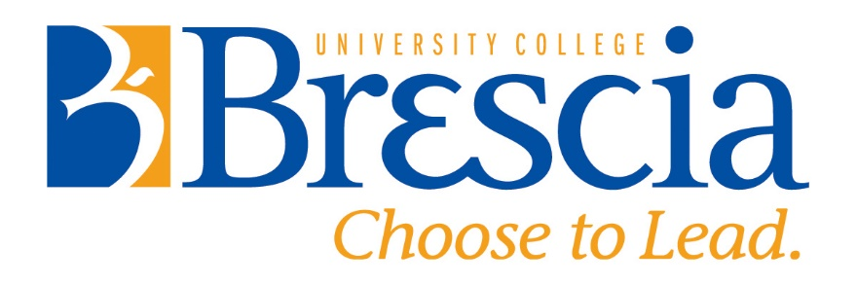

Advanced Learning and Teaching Centre
Faculty Scholar Program
2021-2022 Application Cover Sheet
The goal of the ALT Centre Faculty Scholars Program is to enhance the scholarship of teaching and learning (SOTL) at Brescia by supporting the design, research, and knowledge mobilization of faculty teaching projects. Faculty Scholar projects can be in any area that supports Brescia’s Strategic Plan, including but not limited to women’s education, outcomes-based education, high impact educational practices and international or intercultural education.
Your application should include:
- The completed application cover sheet (below)
- A short summary/press release of the project (maximum 250 words)
- Project proposal (maximum 6 pages)
  - Rationale and outcomes for the project
  - Reason(s) for requesting 0.5 course release
  - Research plan and methods
  - Project timeline
  - Impact of project on learning and teaching at Brescia
  - Suggested opportunities for offering professional development to the Brescia community
- Letter of Support from Chair of School
Please submit your application as a PDF to Michael O’Connor (moconn22@uwo.ca) by 5:00 pm Monday April 19, 2021.

Applicant Name | School
Email | Telephone (office)

Title of Research Project

Does your project require funding? | Yes No
If yes, how do you plan to secure funding? | Brescia Research Grant  Other (please specify)
If applying for a Brescia Research Grant, do you give the ALT Centre Faculty Scholar Review Committee permission to review your Grant application? | Yes No

